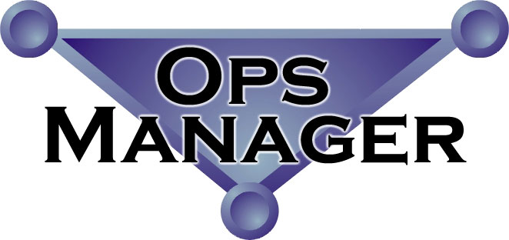
Ops ManagerTM is a resource management program designed to provide companies the ability to better control and track projects, and maintain budgets for their: developers, consultants, trainers, telecommuters or temporary staff. Ops ManagerTM, unlike other software, is a fully functioning system. It is specifically designed to be affordable, versatile, and usable by any company and any industry. Ready “out-of-the-box” or Ops ManagerTM can be customized to fit your particular needs.
Resource Management
For
Companies on the Move

A Product of Resource Company

By incorporating all the necessary information requirements into Ops ManagerTM, we deliver an Enterprise Application Integration (EAI) solution at a cost that any company can afford!

Functions and Modules of Ops ManagerTM include:

Project Administration/Accounting - Empowers Project Manager (PM)
- Manage Account, Project, and Task Info
- Assign Staff to Project Tasks
- Track Budget, Estimate to Complete and Actual Hours
- On-Line TimeSheets correlate to Task Level
- Interface to MS Project
- Bring Contacts from Exchange into Ops Manager
- PM Generate/Review Invoice for Projects, using your Accounting System* or MS Excel
* requires optional accounting interface.

Time Sheets – Convenient access for all employees
- Easy for internal and remote employees to use
- Employees can charge time only to tasks they have been assigned to.
- Record Daily Work Log and Expenses by Task
- Adjustable length, fits any Time Period you select
- Optional Manager Review and Approval Process for time and expenses
- Leave management and time reporting rules**

Multi-National – Supports International Companies and Companies with Foreign Speaking Employees**
- Multi-currency
- Multi-lingual

Human Resources - Enables HR Manager
- Assign Staff to Organizational and Work Teams
- Track Financial Data and Personal Information
- Track Benefits and Benefit Costs
- Track Review status and consequences
- Track User "Codes" for other information
- On-Line TimeSheets track vacation, sick, etc.
- Feed information to employees thru FrontPage News and Ticker Tape Alarms – New Products, staff events, open enrollment, pay period close**
Reporting - Enables Enterprise Reporting
- Integral basic reports in ASP using XML
- Data can be accessed using 3rd party reporting packages (Crystal Reports, et al.)
- OLAP from SQL 7

Interfaces - Convenient access for all employees
- Revenue Recognition
- Invoices
- Payroll information
- Full alias (proxy) capability**

Wireless Application Protocol (WAP) - Provides access thru your WAP-enabled Phone or PDA**

Currently, accounting interfaces have been developed for QuickBooks and Solomon; Payroll interfaces have been developed for Paychex®. Interfaces can be created for most popular packages on a consulting basis.

**Not Available in Virtual IT

Ops ManagerTM is packed with user-friendly interface modules and has received great acclaim from current users. Ops ManagerTM has been chosen as a feature story in an upcoming Discovery series regarding new and useful technologies.

Resource Company

3306 Bourbon Street, Suite 400 – 500

Fredericksburg, VA 22408

Phone: 540-372-9280 - info@resourcecompany.com - Fax: 540-372-9318

